PRACTICAL 11
- Develop a multithreaded counter application using POSIX threads (pthread_create, pthread_join). Demonstrate race conditions by allowing multiple threads to update a shared variable concurrently.
Modify the previous program using mutex locks (pthread_mutex_lock, pthread_mutex_unlock) and compare the outputs with the race-condition version. Analyze the impact of synchronization
SOL:-
1) counter_race.c
#include <stdio.h>
#include <stdlib.h>
#include <pthread.h>

#define NUM_THREADS 5
#define INCREMENTS 100000

int counter = 0; // shared variable

void* increment(void* arg) {
for (int i = 0; i < INCREMENTS; i++) {
counter++; // race condition here
}
return NULL;
}

int main() {
pthread_t threads[NUM_THREADS];

// Create threads
for (int i = 0; i < NUM_THREADS; i++) {
pthread_create(&threads[i], NULL, increment, NULL);
}

// Wait for threads to finish
for (int i = 0; i < NUM_THREADS; i++) {
pthread_join(threads[i], NULL);
}

printf("Final counter value (race condition): %d\n", counter);
return 0;
}
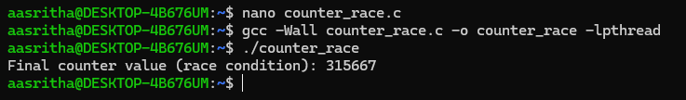
2) counter_mutex.c
#include <stdio.h>
#include <stdlib.h>
#include <pthread.h>

#define NUM_THREADS 5
#define INCREMENTS 100000

int counter = 0; // shared variable
pthread_mutex_t lock; // mutex

void* increment(void* arg) {
for (int i = 0; i < INCREMENTS; i++) {
pthread_mutex_lock(&lock);
counter++;
pthread_mutex_unlock(&lock);
}
return NULL;
}

int main() {
pthread_t threads[NUM_THREADS];
pthread_mutex_init(&lock, NULL);

// Create threads
for (int i = 0; i < NUM_THREADS; i++) {
pthread_create(&threads[i], NULL, increment, NULL);
}

// Wait for threads to finish
for (int i = 0; i < NUM_THREADS; i++) {
pthread_join(threads[i], NULL);
}

pthread_mutex_destroy(&lock);

printf("Final counter value (with mutex): %d\n", counter);
return 0;
}
